The language of graphs and tables

Language-oriented mathematics teaching in professionally oriented contexts

Version 0.9, august 2020
Universiteit Utrecht
in collaboration with Wellant College, Nordwin College, ROC Nijmegen

Colofon
The language of graphs and tables. Language-oriented mathematics teaching in professionally oriented contexts
Version 0.9, august 2020

Erasmus+ Project 2018-2020 - Language for Mathematics in Vocational Contexts

Authors
Monica Wijers, Vincent Jonker, Dédé de Haan en Mieke Abels (Universiteit Utrecht)

With the help of
Iris Speksnijder, Marco van der Schilt, Selma Mulder-Hiemstra, Sjoerd Jacob Heeringa, Peter van Eldonk en Nus Sielcken

Schools involved
Wellantcollege, Nordwin College, ROC Nijmegen

Advice
Heleen Strating, Maaike Hajer

Table of content
Background 5
The project 6
Classroom materials in two parts 6
Part 1 - Communicative situations 6
Part 2 - Course materials 7
Part 1 – Communicative situations 9
Teacher notes 10
Situation A – Tire pressure 10
Situation B – Age and weight of three babies 13
Annex – Example of empty Growth Chart – for situation B on worksheet 15
Worksheet 2 answers – 2 growth charts 16
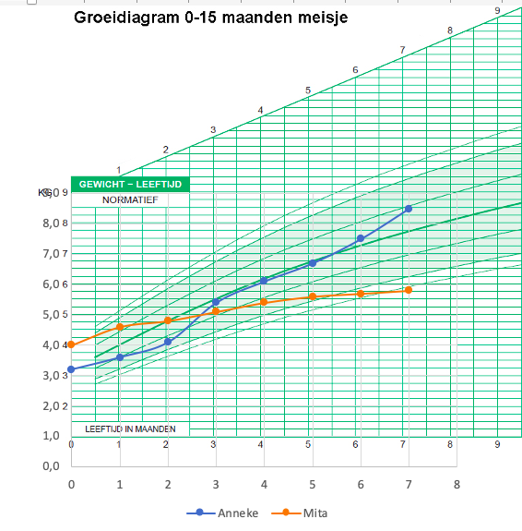 16
Situation C – Travel information 17
Student materials 20
Situation A – Tire pressure 20
Situation B – Growth charts 22
Situation C – Travel advice 26
Part 2 – Lamavoc course in three lessons 28
Teacher notes 29
Lesson 1 – Activating pre-knowledge 29
Lesson 2 – (Line) graphs and language 30
Lesson 3 – Working with different representations 32
Student materials 34
Lesson 1 – Worksheet 1 – Version green 34
Lesson 1 – Worksheet 1 – Version painting 35
Lesson 1 – Worksheet 1 – Version general 36
Lesson 1 – Worksheet 2 – Reading a diagram, interpreting and describing it Version green 37
Lesson 1 – Worksheet 3 – Reflecting on the language of table and bar graph 38
Lesson 2 – Worksheet 5 – Number of goats - Version green 40
Lesson 2 – Worksheet 6 – Matching text and graph - version general 41
Lesson 2 – Worksheet 7 – Line graph and table 42
Lesson 2 – Worksheet 8 – Story and graph 43
Lesson 3 – Worksheet 9 – Cowpats and worms 44
Lesson 3 – Worksheet 10 – Match graph and description 45

Background

The project
Lamavoc aims to develop a teaching approach and teaching units for workplace-related and language-integrated mathematics learning on the mathematical topics fields of percentages, proportional reasoning and functional relationships for vocational classes in the technical and agricultural sector.
On the professional development level, the classroom materials will be integrated into PD programs and PD units in order to professionalize mathematics teachers for workplace-related, language-integrated mathematics classrooms. The PD units comprise materials for classrooms, a teacher manual with didactical and pedagogical hints, material for PD activities and selected video clips.
On the system level, these programs and units will be integrated in existing PD structures of the regions, states and European countries.

Classroom materials in two parts
The module consists of two parts:
- Part 1: Rich communicative situations in a labor setting;
- Part 2: Course materials (3 to four lessons).
Classroom materials from Part 1 & 2 can be used independently and in the order you wish, depending on the skills and experience of the students involved.

Part 1 - Communicative situations
Students are situated in authentic contexts where graphs and tables play an important role. It is very important that students talk with each other to find proper explanations and solutions. It is all about giving an advice, giving the right oral explanation, coming to a decision, etc. It is a kind of role playing, with roles for the client, the manager, the intern, etc.

SITUATIONS
A | Tyre pressure  The context of tire pressure is introduced. Students study a large table with data on tire pressure. Next they do an activity in which they act as junior assistents working at a gas station explaining to customers how they can find the correct tire pressure for their car form the table at the gas station. The product is a script which can be used for a video-clip, a podcast or an acted out role-play.
B | Growth diagram  A growth chart is used to follow a child's growth over time, for health purposes. Another presentation mode is the table, where you see the weight (and length) of a child every month.The weights of three babies have been recorded every month from their day of birth on. Look at the data in the table. What can you tell about these babies? The students are asked to fulfill the vocational task to advice parents about the growth of their babies. With audio recording of the actual conversations about the growth charts both students and teacher get feedback what the actual role is of the 'language of mathematics'.
C | Travel information  In using public transport you need knowledge and skills about online information in order to make a plan for your travel. Information is shown in tables most of the times. In this situation you are asked to help elderly people, both interactively and by writing a manual (for your internship at a local government; the manual can also be a short video). You work in pairs or with three students.

In the conversations the different languages play an important role: mathematics language, school language, vocational language and general language.

Part 2 - Course materials
Part 2 is an extension for Part 1. Students and teachers will have more time to develop a good sense of the 'language of graphs and tables'. There is less attention towards the vocational context, there are more general context.
The teacher is asked to be critical about the chosen contexts, and it is possible to replace the context (the graph, the table) with something that fits both teacher and students (different vocational contexts, it is possible to use graphs with actual information of what happened recently etc.). For each lesson we prepared a manual (with objective and description of the activities), and the worksheets of course.

lesson | Learning strand Graphs/diagrams/tables | Learning strand Language
1 | Activate and re-use previous knowledge about tables and graphs, by using examples of everyday and vocational contexts | Emphasis on oral interaction, by using different kinds of language: everyday language, vocational language and academic (school and mathematical) language. Students mainly talk together and write a little.
2 | Combining different representations: graphs/diagrams, tables and text especially for line-graphs. Know, name and use mathematical characteristics of each representation | (Re-)introduce the (mathematical) language of (line)graphs/diagrams/tables. Make an explicit connection between the mathematical concepts, the mathematical language and the 'situational' language of the vocational or everyday contexts.
3 | Practice the use of different representations and their connections.  Broaden the number and type of representations. If needed include a stronger relation with functions. | Apply the language of mathematics for different representations (fitting situations from home, school and work) and connect this to the (complex) language of vocational situations and everyday situations

In part 2 there is a focus on the following skills:

- Describe a table or graph
Format: oral or paper
Kind of diagram: histogram and line graph. Maybe also: circle diagram and point cloud
Context/situation: general and sometimes vocational
Objectives: use language that fits the situation; recognize context language, vocational language and mathematical language
When: several times, getting more complex

- Compare the different representations (table, diagram/graph)
Format: oral or paper
Objective: understand and describe the different representations with special attention for the mathematics.

- Matching description/title and graph
Format: playing the 'matching game'
Example:
  - add titles to graphs and the other way around
  - match stories and graphs
  - placing 'episodes' in the right order

- Drawing (and describing in own words) a given situation (graph/table)
Format: written
Examples:
  - Use this text (title/story) –> design a graph/table (more or less prefab, with axes e.t.c.
  - Use this graph –> write a title with one or more sentences
  - Use this graph -> construct the underlying table
  - Use this table –> make/convert it towars a diagram/graph
  - Use this diagram/graph –> make another diagram/graph

- Comparing/Judging self produced texts/diagrams (by giving feedback)

Part 1 – Communicative situations

Teacher notes

Situation A – Tire pressure

Summary of activity
The context of tire pressure is introduced. Students study a large table with data on tire pressure and advices about extra pressure.
Source: https://da6i906t0wseh.cloudfront.net/general/bandenspanningstabel.pdf?mtime=20190826133206&focal=none
Next they do an activity in which they act as junior assistents working at a gas station explaining to customers how they can find the correct tire pressure for their car form the table at the gas station.
The product is a script which can be used for a video-clip, a podcast or an acted out role-play.

Goals
- Getting to know the context and ist language (symbols, units, …)
- Find specific information in the table using the structue of the table, interpret the texts about ext pressure.
- Reason about percentages and the order of operations when numbers as well as percentages are being used.
- Communicate (written and orally): explain how to find information in a table and how to calculate the extra pressure, using approriate language.

Language in task
Rich communicative practice: Explanation
Students use the following concepts in an appropriate and correct way (whole sentences) in their explanations both orally and in writing
Context: (tyre) pressure, front axle, rear axle, units: bar and kilopascal (kpa), tyre size, brand names and type names and other indication of car (engine power).
Mathematics: table, row, column, numbers and their meaning (name numbers, values, etc.), language of calculations/operations.
Sample sentences
"You first look in the table for what kind of car it is. You're looking at the first letter. And then you look in the last column what the tyre pressure is."
"You add 10%, first you divide the number of the tyre pressure by 10 and then you add that result."

Suggested lesson plan
Introduction (10-15 minutes) – whole class discussion
- Going through and discussing the situation: is this familiar for students? Do they know what tyre pressure is (what about a bike)? Do they ever come to a gas station?
- Invite students to explore the table in pairs using the legend. What information is in it, how is it structured? What do the numbers mean? What information is needed for tyre pressure? Then discuss the questions students have.
- Students read the advice below the table. Do they know all the words/concepts?
Tip: Ask them to think in pairs how they can come to a good advice about the tyre pressure for the customer (look up, calculate). Don't give any clues (yet). It is more interesting to leave the thinking to the groups when they start working on the script.
Get started with the script – instruction whole class and work in triples (15 minutes)
- Briefly explain the purpose of the assignment. Discuss which elements are important in the explanations students will give.
- Students devise and write a script in small groups of 2 or 3 (see assignment) and may already make a recording. Tip: Build in a check, to talk through their script with each group.
Execution (10 - 15 minutes or homework)
Create/perform video, podcast or role play.

Reflection and feedback (15 minutes)
There are several possibilities for this. Students can give each other feedback. When giving feedback, pay attention to both the content and form. Pay attention to the language as well as to the mathematical aspects.

Experiences and tips
Some students immediately calculate the extra pressure based on the advices (+0.2 bar and/or 10% extra tension). Point out to them that they also need to explain how to search the table. Give language support, for example:
- ask what information is needed to determine the correct tyre pressure for a car (brand and type of car, summer-winter, load, ...)
- name words they can use in that explanation (row, column, alfabetically, )
- give a fill-in schedule (language-frame), for example. First you look for ...., then you look at .... Etc.
- Act yourself as a "not so clever" customer.
Some students use one of two advices in their explanation: 10% extra or 0.2 bar, some Some students either use the 10% extra or the 0.2 bar (extra for winter tyres) some will combine both. You may ask students to think about the following: will it make a difference in which order you add the extra pressure: 10% and 0.2 bar?

Examples from the pilot
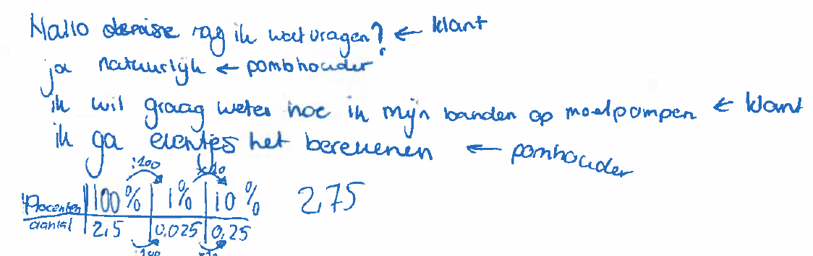
Hello, can I ask you something? (<-customer)
Yes of course (<- gas station assistant)
I want to know how to pump my tyres for extra pressure (<-customer)
I will calculate it for you (<-gas station assistant)

percents | 100% | 1% | 10%
number | 2,5 | 0,025 | 0,25

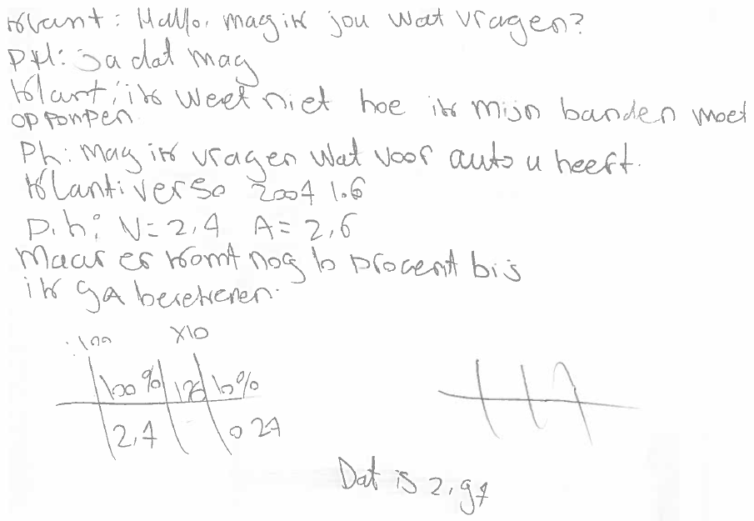

Customer: hello, can I ask you something?
PH: Yes, you can
Cust: I don’t knowhow to pump my tyres
Ph: can I ask you wht kind of car you have?
Cust: Verso 2007 1.6
Ph: V= 2,4 A =2,6 [V is front axle. A is back axle]
But an additional 10% is needed. I will calculate this [see table and answer 2.97]

Situation B – Age and weight of three babies

Summary of activity
The activity is about growth charts. First, this context is introduced. The students then study one or more growth diagrams. In the second part of the activity, the students have the role of intern at a child healthcare centre. Their role is to answer questions from parents about growth charts. They write down their answer and then record it with their phone (audio). If the step to the second part is too large, an additional worksheet is available to practice creating growth charts

Source:
www.tno.nl/nl/aandachtsgebieden/gezond-leven/roadmaps/youth/groeidiagrammen-in-pdf-formaat/

Goals
- Becoming familiar with growth charts (or graphs) as used at the child healthcare centre to track the growth of babies.
- Read and interpret growth charts
- Create a growth chart from a table of data
- Give correct and understandable answers – oral and written – to questions about growth charts.

Relevant language
Students use the following concepts in an appropriate and correct way (whole sentences) in their explanations orally and in writing
Context: child health care centre, growth, growth diagram, growth booklet, weigh, weight in kg, measure length in cm, age in months
Mathematics: (growth) chart, (growth) diagram, axes, step size, rise, decline, average, ‘speed’ of growth
Sample sentences:
- In the beginning a baby grows very fast in length, if the baby is 6 months he grows less fast.
- This baby is not that big, but it grows exactly along one of the lines
- This baby has grown from 55 cm to 67 cm in six months, which is on average 2 cm per month.

Suggested lesson plan
Introduction (15 minutes) – whole class discussion
- Discuss the situation: is this familiar to students? Do they know what a baby health care center is? Do they know how babies are weighed and measured? Have they ever seen a growth chart? Do they have a growth booklet of their own?
If helpful, use this (Dutch) video or find a local one yourself: https://www.youtube.com/watch?v=8hXo3q27heM
- Question 1 and 2: Let students discuss these in pairs first. Then go through the answers together. Pay attention to:
  - The relevance of tracking growth in order to be able to determine on time whether there are problems (question 1).
  - The information from the diagram in the example (question 2). The diagram shows age in months (horizontal axis) and length in cm (vertical axis, step size 2 cm). The blue dots are the lengths of a baby/child. The green areas indicate the extent to which the growth corresponds to that of the average baby. The middle line shows the growth of the average baby. The other lines are for smaller or larger babies. It is important that a baby 'stays on his/her own line' as much as possible. The baby in the example (blue dots) is therefore relatively small and grows well. For your information: The numbers in the legend indicate deviations from the average in standard deviations (this concept does not need to know the lln).
- Question 3: Together with the students, review other growth charts, such as those for weight on worksheet 2. Ask questions like: why are there different versions for boys and girls? what are the differences? Also, see one or more full growth charts on the TNO website (or your local one) site https://www.tno.nl/nl/aandachtsgebieden/gezond-leven/roadmaps/youth/groeidiagrammen-in-pdf-formaat/ (see also Annex 1 for an example). Questions: why are there different diagrams for different ages (has to do with scale) and for different population groups (has to do with average lengths in populations).
Final assignment (20 minutes) – worksheet 1 -> give advice to parents
- Briefly explain what the aim is. Discuss what elements are important in the answer they are going to give to the parents.
- Students in in small groups (2 or 3) choose one of the three questions on worksheet 1. It is also possible as a teacher to divide the questions. Together they come up with an answer to the question and write it down, then they make an audio recording (with their phone). If necessary, build in a check: go through their text with each group.
- Tip: If students find the subject difficult, choose to have them do the practice assignments on worksheet 2 before they complete the final assignment. In this assignment, the students look at a table of data on the weight of three babies and make statements about the growth based on this. They then create three growth charts of the data in the table and make statements about growth based on them. See Annex 2 for growth charts.
Reflection and feedback (15 minutes)
There are several possibilities for this. Students with the same question can give each other feedback and possibly come together for a single response. When providing feedback, pay attention to both the content and the form. Pay attention to both the use of language (see goals) and mathematics.

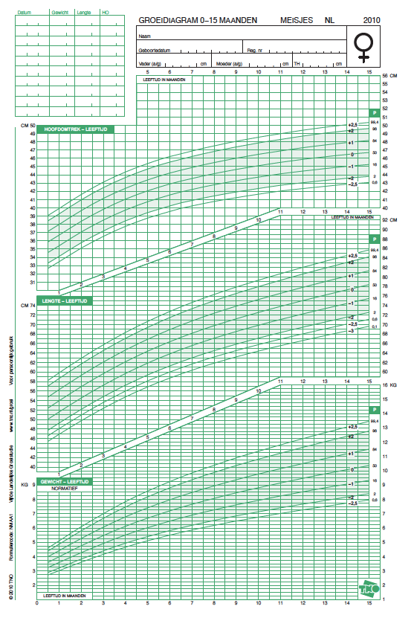

Annex – Example of empty Growth Chart – for situation B on worksheet

Worksheet 2 answers – 2 growth charts

Situation C – Travel information

Summary of activity
The activity is about giving a travel advice (using PUBLIC TRANSPORT) and making a manual on how to find a travel advice yourself. First, the context is briefly introduced. Students in small groups will then give a travel advice for the specific situation in the assignment.
In the second part of the assignment they make a manual for the finding a travel advice, they have the role of intern at the municipality. This can be a written manual (with illustrations) or a movie.

Goals
- Get familiar with the ways (and tools) to get travel advice for public transport.
- Read and interpret various types of schedules and tables related to travel advice, knowing the symbols used.
- Calcualte and estimate distances and (travel) times
- Give a correct and understandable explanation – oral and written – about finding and interpreting a travel advice (with the public transport).

Relevant language
Students use the following concepts in an appropriate and correct way (whole sentences) in their explanations orally and in writing
Context: travel, departure, arrival, travel time, transfer, means of transport, destination, options, line, rail, stop, platform, via, ... [also: the various symbols]
Mathematics: time (in hours and minutes, various notations), duration, travel time, speed
Sample phrases:
- If you leave at eight o'clock you will be at your destination 1 hour and 7 minutes later. That's at about 10 minutes past 9 o’clock
- You have to transfer to line 3 and get off at the mall. Then it's another five minutes' walk.
- First enter the address you depart from and then the address you want to go to. Then choose time of arrival or time of departure.

Suggested lesson plan
Introduction (5 minutes) – whole class discussion
Discuss the situation: do the students ever travel with public transport? Do they plan their trip, and if so, how? Do they know sites (and physical places) where they can get travel information?
Give travel advice (10 minutes) – small groups
- Assignment 1: First invite students in small groups to come up with a plan on how to find the requested travel plan and then carry it out it. Task 3 can be used for the groups that finish task 1 very quickly. They can work on task 3 before task 2. You may also present the more complex version of the task to the more ‘able’ students.
- It is also possible to change the assignment into a version that connects more to students’ own experiences: for example, the route from school to an internship. In that case you can keep the format and the tasks but change the point of departure to one close to school. You can also have them give advice to a ‘foreign’ friend or relative instead of an elderly couple.
- For this assignment, the students need a computer/tablet with internet connection or a phone with appropriate apps. Ask them to keep track of the sources used. Discuss the travel advices (compare travel duration, number of transfers, distance, etc.) and discuss how they are 'found'.
Create a guide to find a travel advice (20 minutes)
- Together with students go through the assignment. Briefly explain what the intention is. Discuss together which elements are important in the manual they are going to create. Give students in the choice to make a paper manual (with illustrations), or a movie.
- Have students in small groups, first make a setup (for paper) or a script for a movie. Have a go-no go.
Reflection and feedback (15 minutes)
There are several possibilities for this. Students can first give each other feedback. When providing feedback, pay attention to both the content and the form. Pay attention to both the use of language (see goals) and the mathematical aspects.

Example of sources and solutions:
First part per bus
Source 1 bus: https://9292.nl/  'where do you want to go?'  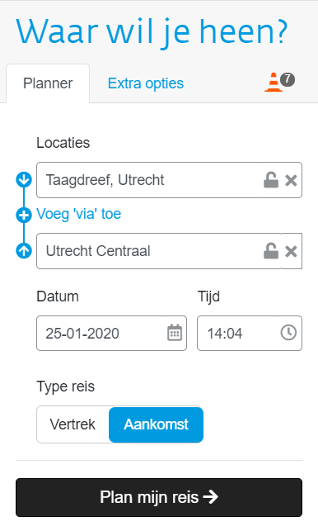 | Source 2 bus: https://www.google.nl/maps  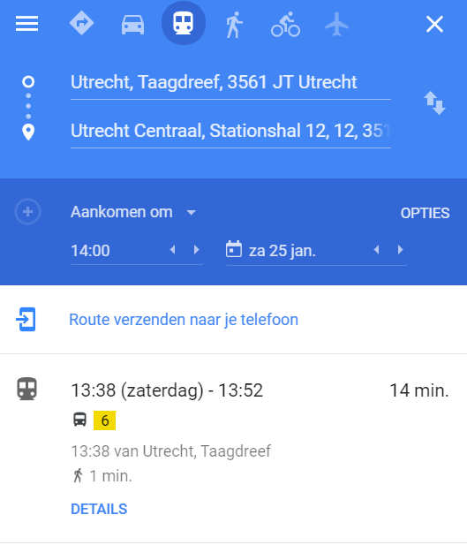

Travel by train: www.ns.nl
'Plan your journey'
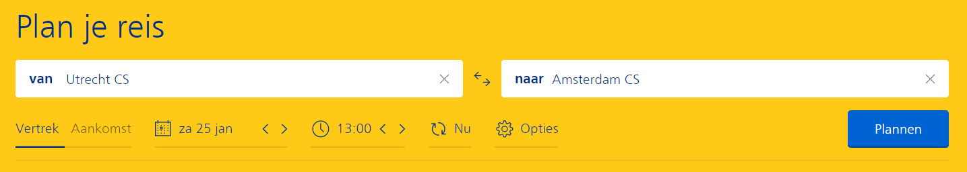

Follow up screen.
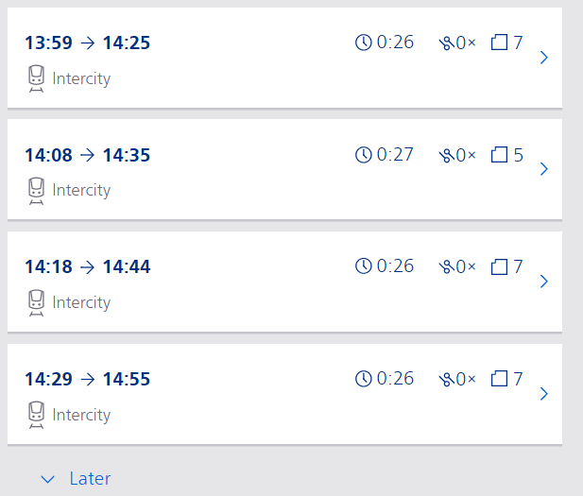

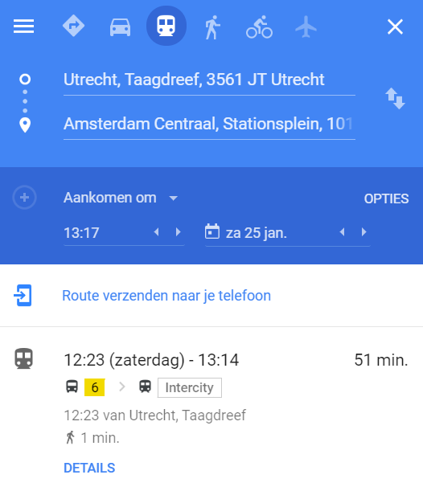
Google maps and 9292.nl give the whole journey at once

Student materials

Situation A – Tire pressure

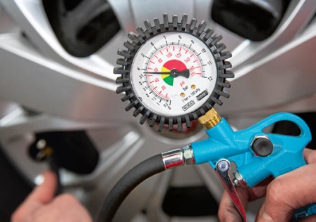
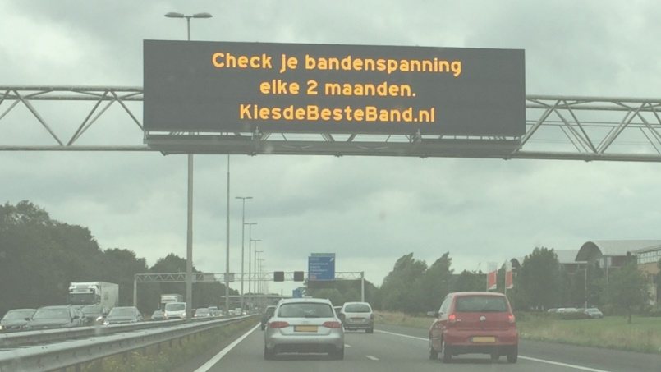
Check your tire pressure every two months

Most gas station have an automatic air pump to fill the air in your car’s tires. Close to the pump is a table with recommended tire pressures for all types of cars.

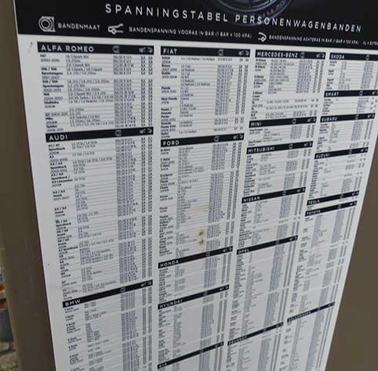

Listed in the head pf the table you find this informatio. It is a kind of legenda for reading the table
Tyre size Tire pressure for front axle Tire pressure for back axle
Below part of the tire pressure table is enlarged.
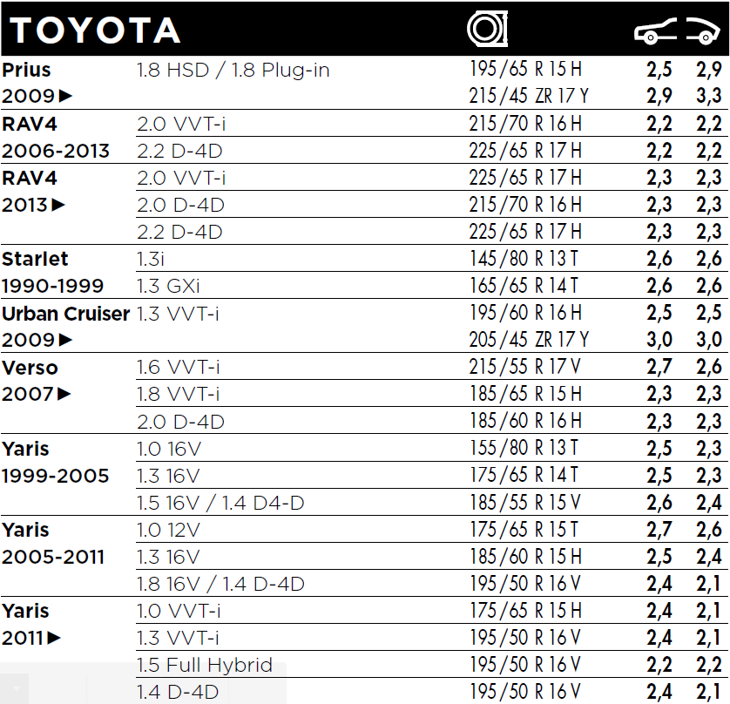

Task

Higher tire pressure
Driving with a tire pressure that is higher than the recommended pressure is less of a problem, than driving with a tire pressure that is too low. The advice is to drive with a tire pressure that is 10% higher than the value recommended. You should also adjust the tire pressure the circumstances.

Tire pressure for winter tires
If your car has winter tires we advise to add 0.2 bar to the pressure value in the table. Do not forget to check the pressure of your spare tire.
A lot of car owners do not know what the correct tire pressure is for their car.
You have the role of a junior assistent working at a gas station. Your task is to explain customers how they can find the correct tire pressure for their car form the table at the gas station. You can either make a small movie or a podcast. For either of this options you will need to write a script. In the script you write the full texts that will be spoken.

Situation B – Growth charts

Introduction
The growth of a baby is monitored by weighing the baby every month and putting the data in a chart.

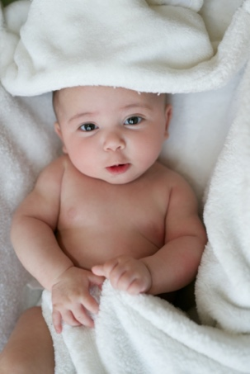  What is the purpose of following the growth of a baby?  At the right you see a growth chart with information about weight (an length) and growth.  Have a discussion (in pairs or in the whole group) about what you see. | 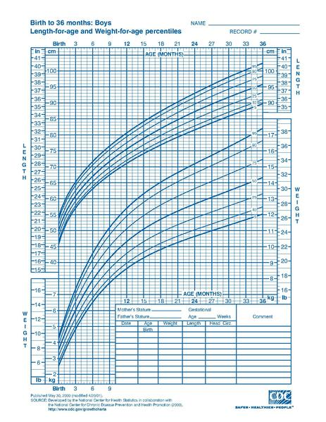  Growth chart (source: wikipedia)

Central Question
Imagine you work at a child health care center during your internship. Parents have questions about the growth of their baby. Your coach tells you that you can answer the parents questions ‘since you learned about diagrams and graphs in school’ and this a good situation to use your experience and skills.

On Worksheet 1 you see three questions. Choose a question and think about your answer. What will you tell the parent(s)? Briefly write down your answer and record it with your phone (make an audio file). Listen to your explanation and improve your answer. Work together with a peer student.

Note: If you like to have extra practice in making growth diagram use Worksheet 2 (Age and weight of three babies).

Lamavoc growth charts - Worksheet 1 - Three questions

Mother of Anika
Anika is not following a straight line in her growth. It is not linear. Is this okay?

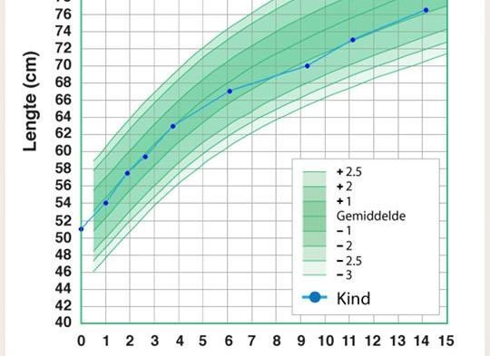
Father of Ali
Ali is now over one year of age. It seems like his growth curve is 'going down', the blue dots are no longer on the green line in the middle. Should we worry about this?

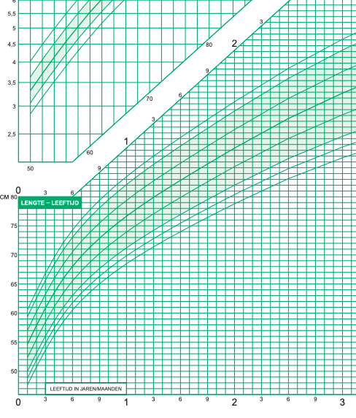
Mother of Wesley
Wesley is 3 years old. I have heard that a child needs to grow 2 cm in height each month. Is this correct and how can I see this in the diagram? Please explain this to me.

Lamavoc - growth charts Worksheet 2 - Age and weight of three babies

Task 1
The weights of three babies have been recorded every month from their day of birth on.
- Why would someone do this?
- Look at the data in the table. What can you tell about these babies?
 | Weight in kg
Age in months | Anneke  (girl) | Mita  (girl) | Danny  (boy)
0 | 3,2 | 4,0 | 3,4
1 | 3,6 | 4,6 | 4,5
2 | 4,1 | 4,8 | 5,6
3 | 5,4 | 5,1 | 6,4
4 | 6,1 | 5,4 | 7,0
5 | 6,7 | 5,6 | 7,4
6 | 7,5 | 5,7 | 7,9
7 | 8,5 | 5,8 | 8,3

Task 2
In task 1 you used a table. Now we will look at a graph. In a graph you can more easily see how the baby grows. There are special graphs to show the growth: these are called 'growth charts'.

On the worksheet you can see one diagram with seven growth curves (the curved lines).
The middle curve represents the growth of an ‘average’ baby.
Almost no baby really grows perfectly along this line. If the baby’s weight stays between the upper and lower curve AND the weight follows the shape of the curves than it is okay.
- Use the data from the table to make a growth curve of the weight of each of the three babies.
- Discuss with a classmate what you would tell each of the parents: should they worry about their baby’s growth? Why or why not?

boy
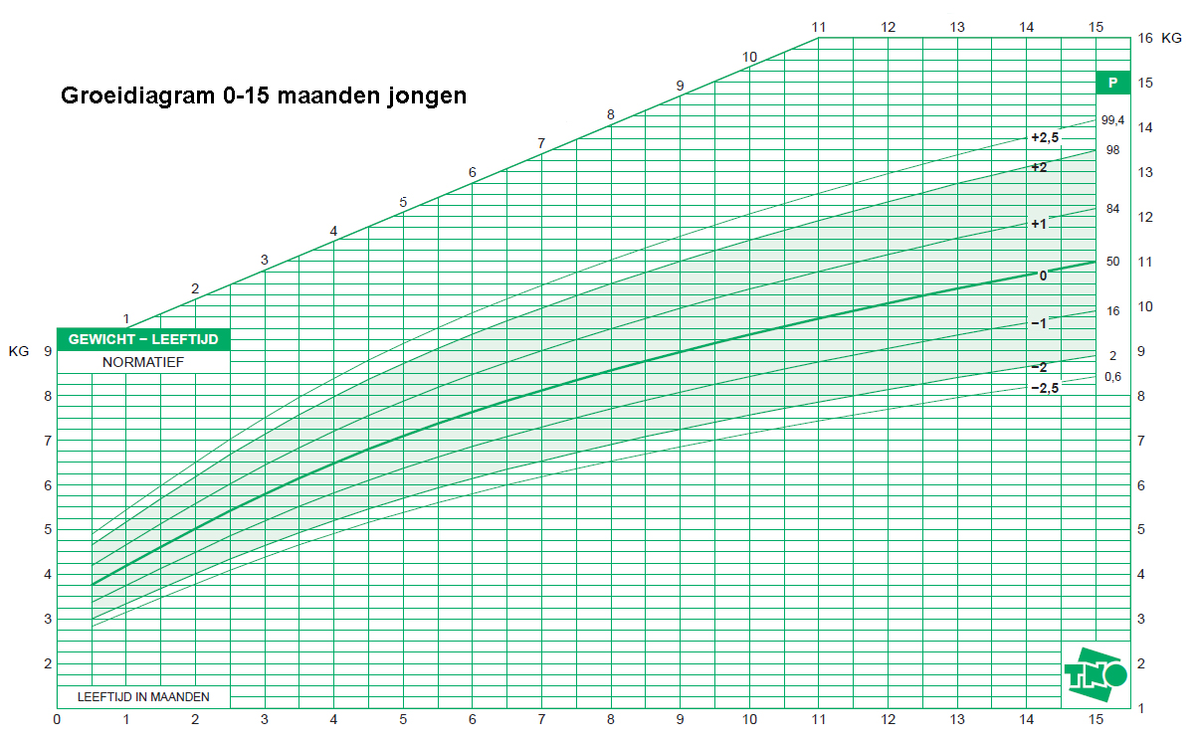

girl
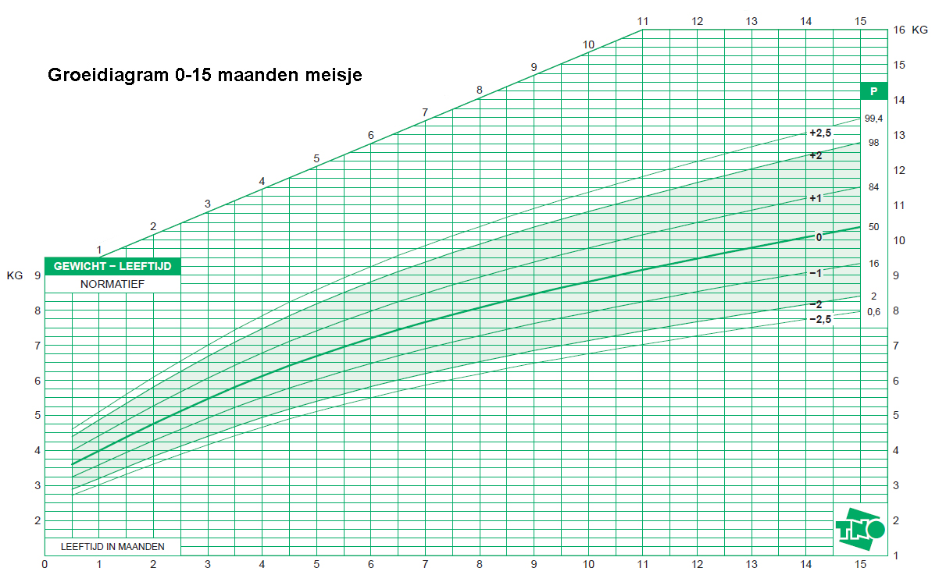

Task 3
Suppose a pupil from another school sees the growths curves you have made, and wants to know what these curves mean and how you can make decisions based on these curves.
Explain this and record your spoken explanation with your mobile phone.

Situation C – Travel advice

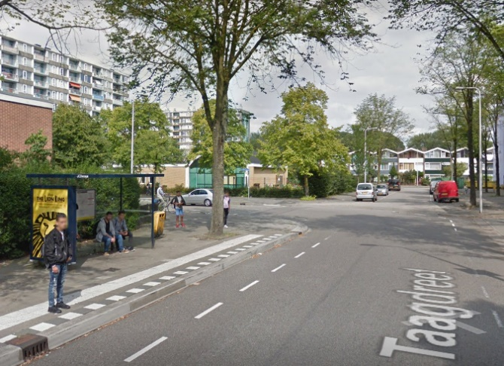
You will advice an elderly couple about travelling by public transport.

The couple lives [at street – city] and wants to travel on Saturday by public transport to [big city central station – not too far away]. They will meet friends there at 12:00 noon.

The couple doesn’t know at what time they should depart from home to be on time at [big city central station – not too far away].
They also have no idea how and where they can find this kind of information.

Task 1
- In your small team discuss how you will work out this problem. What is your way of working? What sources do you use? etc.
- Write down your plan of action.
- Search for the information you need on the internet. Write down your travel-advice.

Task 2
Work with two small groups together in a role play.
Two people from one group represent ‘the couple’, two from the other group give the advice.
Do this in the form of a conversation and record the audio.
Change roles and do it again.

Task 3
The couple is happy with your advice. But they want to be able themselves to plan their travel with public transport.
They possess a mobile phone and a tablet both with a connection to the internet.
Write a compact instruction how to plan travel with public transport using the internet.

Lamavoc - Travel information (more complex)
You will advice an elderly couple about travelling by public transport.

The couple lives [at street – city] , they want to go to a concert next Saturday in [big city, theatre]. The show starts at 16:00.

The couple doesn’t know at what time they should depart from home to be on time at [big city theatre].
They also have no idea how and where they can find this kind of information.

Task 1
- In your small team discuss how you will work out this problem. What is your way of working? What sources do you use? etc.
- Write down your plan of action.
- Search for the information you need on the internet. Write down your travel-advice.
Task 2
Work with two small groups together in a role play.
Two people from one group represent ‘the couple’, two from the other group give the advice.
Do this in the form of a conversation and record the audio.
Change roles and do it again.

Task 3
The couple is happy with your advice. But they want to be able themselves to plan their travel with public transport.
The couple has a mobile phone and a tablet both with a connection to the internet.
Write a compact instruction how to plan travel with public transport using the internet.

Part 2 – Lamavoc course in three lessons

Teacher notes

Lesson 1 – Activating pre-knowledge

Objectives
- Students describe a table or graph (including line graphs and bar/pie charts) in correct and understandable language for daily life or a vocational setting. They make use of both 'daily' language and jargon from the area of mathematics, and, if necessary, also jargon from a vocational area.
- Students understand the structure of a table and some graphs. They can label parts of the 'interface' of both tables and graphs, by using the appropriate language. They know what characteristics of tables and graphs are common and useful in specific situations.

Activities
- Describe the table (orally) – see worksheet 1
Present a common table from a vocational context, well known to the group of students. Choose one.
  - What is it all about?
Ask the students to describe what they see/understand of the purpose of the table (what information is collected in the table; etc. ).
First give students some time individually to think, then in pairs and then the whole group (Think, Pair, Share). If necessary write down more 'complex' concepts/words (from the vocational or mathematical setting) on the whiteboard.
  - What are the characteristics of a table?
Let students work in pairs on the so-called 'word web' (or work with a list). This will be re-used in activity 3.

- Decribe a diagram (orally) – see worksheet 2.
This activity is analog to activity 1, but now working with a diagram from a vocational setting, for example a bar chart of another frequently used type of graph. Choose yourself.

- Compare table and diagram – see worksheet 3
a. use characteristics and/or parts of the table/graph
Let the group of students work together to make an overview of characteristics/parts bij bringing together the different 'word webs'.
  - If chosen words are the same in interpretation or almost the same, please pay attenttion to this phenomenon, e.g. 'box' and 'element' in a table; or 'axis' or 'horizontally' in a line graph, or 'bar' or 'rod' in a bar chart.
  - Check if all (important) parts are mentioned. Otherwise ask : 'How do you call... '.
b. use purpose
Ask two students to think what they would choose in that particular setting, talking about advantages and disadvantages; Ask to choose between different representations in particular settings. A question to guide the students: 'Would it be better to choose a graph in stead of a table (Worksheet 1), and vice versa in Worksheet 2?'
Discuss it with the whole group.

- Manually describe a table or graph (Worksheet 4).
Here you see the conversion from oral description to handwritten description. The is the first time (after Worksheet 1 to 3) to be more precise about what to write down in your own words (for somebody else to understand).
Collect the worksheets to give feedback about what students wrote down, this can be used in the next lessons.

Lesson 2 – (Line) graphs and language

Objectives
- Students can work with the mathematical language (e.g. axes, rise, decline, constant), that is appropriate for the line graphs where time is on the horizontal axe and where they use mathematical language (both orally and handwritten) properly and correct to describe a line graph.
- Students can combine a text and a graph and can explain what makes the connection between text and graph. They do this by using appropriate mathematical language.
- Students can distinguish mathematical language, daily language and jargon when they talk and write about graphs.

Activities
- Describe a line graph (see Worksheet 5).
In this activity there is a central line graph with time on the horizontal axis. This can be a line graph extracted from a vocational context (but sometimes it is hard to find a good example) or by presenting a daily situation that preferrably deals with growth (increase and decrease).
Be sure not to use a time-distance graph (they are more complex to understand, and will follow in week 3).
Use the same order as in activity 1 and 2 from lesson 1: first decribe the line graph (what kind of information do you see? How do you use it?), then working on a list of characteristics (a language list), first in pairs and then in the whole group. At least pay attention to the axes (and how all details work) and the actual information in the graph and how this is related to the (vocational) context and the specific jargon, but also the mathematical language ('increase', etc.).

- Match line graph and titles/texts (see Worksheet 6).
Start with an example (in the whole group): choose one line graph with three stories (title/text). Let students explain why they see a match. In the next step you work in smaller groups.
Students discuss the matching between graph and text. When all students return to the whole group they will be asked what the actual language is (both mathematical and also jargon and daily life) that makes the match. Look back at the list of words in activity 1. It is important to be clear about the axes: what concept and quantity (and what unit). In the next activity the number of words (concepts) will be extended.

Make a distinction between the daily language and the vocationale language and the mathematical language. Make this clear by using an example, e.g. the situation below that Wim tries to lose weight.

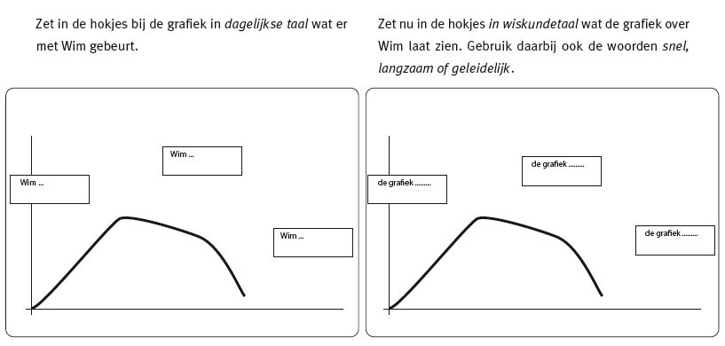
Subsequently you can work with letting the students draw the graph (e.g. by using mini-whiteboards).

- Mathematical language and line graphs (see worksheet 7).
In this activity you work on expanding the repertoire of mathematical language in order to describe line graphs. For example:
stijgen, dalen, oplopen, aflopen, steil, vlak, horizontaal, hellend, top, piek, dal, laagste punt, hoogste punt, sprong, scherp, glad, rond, hoekig, stotend, plotselinge verandering, knik, met een schok, golvend, herhalend, zaagtand, vloeiend, rustig, onregelmatig, slingerend, wild, chaotisch.

You can also mention 'fast increase', ' 'decreasing growth', 'top', 'maximum', 'intersection' etc. Let the students first work with activity A individually and then work in pairs. In the whole group you can evaluate which sentences are used, and which are correct or not, when you formulate it mathematically (e.g. 'the line graph does not move').
Collect the answers to activity B. Give feedback on the use of language and the distinction between the context language and the mathematical language.

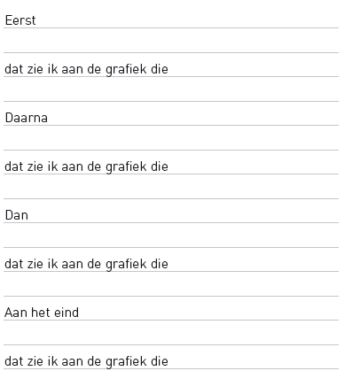
- Combine mathematical language and context language (vocational or daily settings), see Worksheet 8. You will re-use the graphs of Worksheet 6, and you can also choose your own graphs (from vocational or daily settings).
Students will describe the setting and make this description (mathematically) match with the description of the graph. This is supported by 'fill up sentences'.

Ask students to make a text that fits to a line graph. Give feedback and take the answers to lesson 3.

Lesson 3 – Working with different representations

Objectives
- Students can explain the connection between a text and a table and/or graph.
- Students are able to match different representations of the same situation.
- Students evaluate data from different representations (table, different graphs like a line graph and a bar chart).
- Students can choose and design an alternative representation with a given context/representation, they learn to match text, table and graph.
- Students learn to choose a correct representation that helps in solving the problem.

Activities
- Worksheet 9: Evaluate texts that are matched to a table and/or graph.
Students (in pairs) will evaluate some texts from other students, and will formulate feedback. Make use of the student work from the previous lessons (this can also be other student work). Try to choose (together with the whoe group) the 'best description' (match). Continue to be clear about mathematical language (e.g. the 'graph shows an increase') and the context language ('the sunflower grows longer').
- Worksheet 10: match table, graph and text
Use the cards with graphs and text (and maybe the tables)
Students have to combine representations in a kind of game: text and graph. You can also match two diagrams (a line graph and and a pie chart), and also a matching text.
You can leave empty some cards for own production by students. You should preferrably choose contexts (from daily life and vocational settings) that are close to your group of students. Evaluate it in the whole group, and let students explain why they think there is a good match. Please give feedback on their use of the different languages (mathematical, jargon and daily life).

Student materials

Lesson 1 – Worksheet 1 – Version green
Reading a table, interpreting and describing it. Look at the table below.

crop | germinating temperature (°C )
 | minimum | optimum | maximum
cichory | 5 | 25 | 30
root beans | 10 | 14 | 30
beets | 3 | 20 | 28
turnip cabbage | 5 | 20-25 | 29
corn | 8 | 30 | 40
peas | 1 | 12-16 | 40

Discuss and answer the following questions together:

- Describe the meaning of the following words from the table:
  - Crop
  - Germinating temperature
  - Minimum
  - Optimum
  - Maximum

- What does this table give information about?

- In what kind of situation can you use this table?

- Come up with a fitting (short) title for this table.

Below, there are two sentences about the information in the table:
“The minimum germinating temperature for beets is 3 °C.”
“Corn has the highest germinating temperature.”

- Make two more sentences for this table yourself.

- Also make a question that you could answer with the information from this table.

Look at the table again.
- How many columns does the table have?
- How many rows?
How many cells?

Lesson 1 – Worksheet 1 – Version painting

Look at the table in the precalculation form below.
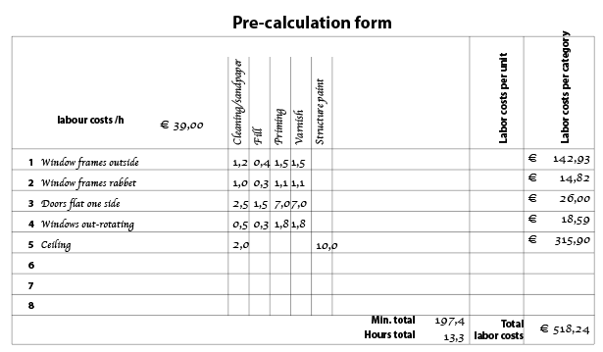

Discuss and answer the following questions together:

- Describe the meaning of the following words from the table.
  - Precalculation
  - Interior work
  - Window sills
  - Reapply primer

- What is this table about? What information does it give?

- In what kind of situation can you use this table?

- Complete the sentences so that they match the information in the table.

The ……………………. of …………………………. takes ……………….. minutes
The processing time is the highest for the ……………….. of …………………

- Also make a sentence for the information in this table yourself.

What parts does this table have? Make a list or write down the names next to the table

Lesson 1 – Worksheet 1 – Version general

Look at the table below.
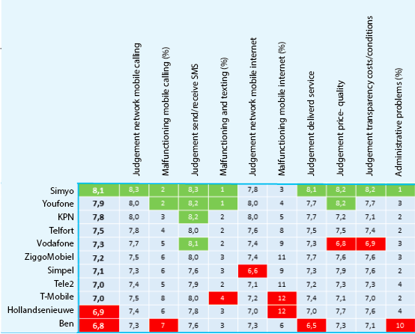

Discuss and answer the following questions together:
- What is this table about? What can you use this table for?
- What do the following words from the table mean:
  - Test review
  - Network mobile calling
  - SMS

In the table you can see columns with decimal numbers between 0 and 10 and columns with whole percentages (%).
- Why is, in the columns with percentages, the highest number red and the lowest green?
- Why is, in the columns with numbers, the highest number green and the lowest red?

- Come up with a fitting (short) title for this table.

Below, there are two sentences about the information in the table:
“Ben has the lowest rating for the entire test review.”
“The percentage of interrupted service for mobile internet is between 3% and 12%.
- Make two more sentences for this table yourself.

Look at the table again.
How many columns does the table have? How many rows? How many cells?

Lesson 1 – Worksheet 2 – Reading a diagram, interpreting and describing it Version green

Look at the diagram below together.
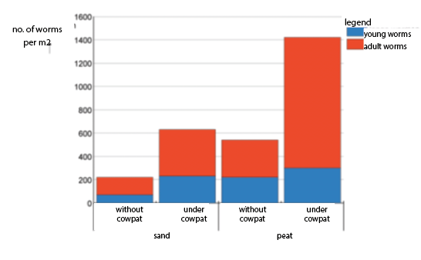

Discuss and answer the following questions

- What do you call this type of diagram?

- Explain to your neighbour what the diagram is about.

- Come up with a fitting (short) title for this diagram.

- Circle the right word, so that the sentence matches the diagram:

Most …old/young………… worms can be found in …sand/peat……………. without/under a cowpat

Cowpats are …good/bad…………. for worms.

Look at the diagram again.

- What parts does this diagram have?

Lesson 1 – Worksheet 3 – Reflecting on the language of table and bar graph

Table

Make a 'word web' with the words that go with 'table'

Using a table is easy because:

A table is useful for:

In a table you can easily:

Bar graph
Make a 'word web' with the words that go with 'bar graph'

Using a bar graph is handy because:

A bar graph is useful for:

In a bar graph you can easily:

Task
Now compare the bar graph and the table.
Discuss with your peers which representation you prefer and why.

Lesson 2 – Worksheet 5 – Number of goats - Version green

Look at the line graph below ("the number of goats in the Netherlands 2000-2018")
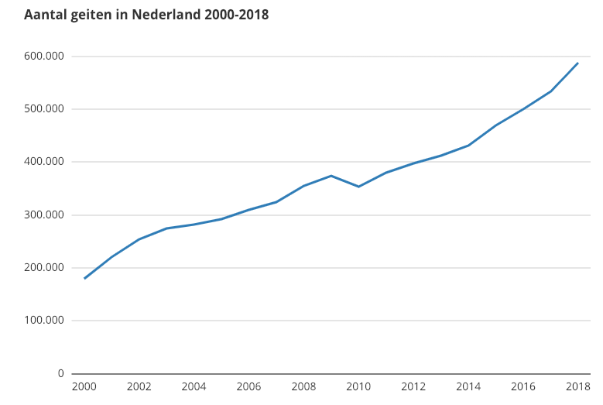

Discuss and answer the following questions
- What is the graph about?
- What do you notice?

Tell the story that goes with the graph.
- Record your story with your mobile phone.

Listen to the stories in pairs and discuss them together.
Which are the most important words in your story?
Write them down below.

Lesson 2 – Worksheet 6 – Matching text and graph - version general

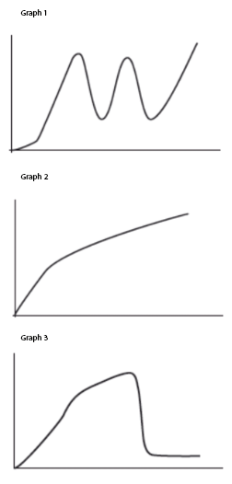
Answer and explain:

Graph 1
Title .... matches this graph, because …….

The horizontal axis has the label ……..
The vertical axis has the label ……

Graph 2
Title .... matches this graph, because …….

The horizontal axis has the label ……..
The vertical axis has the label ……

Graph 3
Title .... matches this graph, because …….

The horizontal axis has the label ……..
The vertical axis has the label ……

Which title matches which graph?

Title A
The total number of downloaded Kendrick Lamar songs

Title B
The number of views of a youtube video

Title C
The mood of the coach during a football match

Lesson 2 – Worksheet 7 – Line graph and table
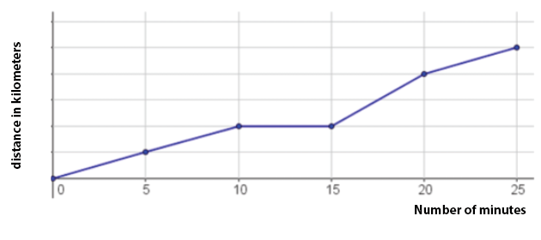

Here is the graph from Sep’s bicycle tour again.
- Put the data from the bicycle tour in a table. Sep left home at 08:00 a.m.

Number of minutes | 0
Time | 8:00
Distance covered in km | 0

Answer the questions below.
Indicate for each question whether you think it is simpler to use the graph, or the table.

- At what time did Sep reach his destination? ……………. Simpler with graph/table
- How long was Sep’s speed stationary? ……………. Simpler with graph/table
- In which section did Sep go fastest? ……………. Simpler with graph/table

- How many km did Sep cycle in total? ……………. Simpler with graph/table

- How far did Sep have left to go after 20 minutes? ……………. Simpler with graph/table

- In which sections did Sep have the same speed? ……………… Simpler with graph/table

Lesson 2 – Worksheet 8 – Story and graph

Here you see three graphs (from Worksheet 6). Use the titles you found in Worksheet 6.  Please choose two graphs and describe them by using the schedule below.  Graph ('grafiek') …..  First ...  because the graph ...  Then...  because the graph ...  At the end ...  because the graph ...  Graph …..  First ...  because the graph ...  Then...  because the graph ...  At the end ...  because the graph ... | 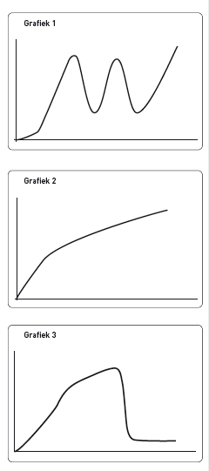

Lesson 3 – Worksheet 9 – Cowpats and worms
Look at this bar chart
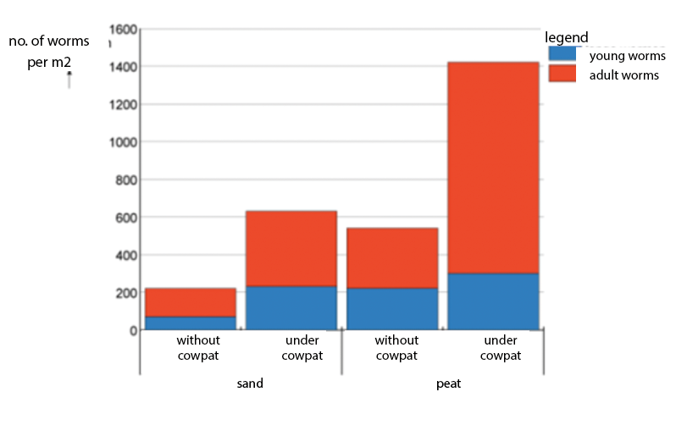

Students were asked to describe what they see in this graph. Please order the student answers in the order 'excellent' to 'poor'. Explain.

Student 1:
Number of worms in the cowpat
Young/adult worms

Student 2:
About cowpat and sand and peat

Student 3:
How many worms there are in different types of sand

Student 4:
Number of worms per m²

Student 5:
About worms in something the number

Student 6:
How many worms can be in diferent types of soil

Student 7:
There are worms in the table per m²

Lesson 3 – Worksheet 10 – Match graph and description

Graphs  A I choose description nr: because:  B I choose description nr: because:  C I choose description nr: because:  D I choose description nr: because: | Descriptions  1 The length of a human being during life.  2 The temperature during one day.  3 Height of weed during a couple of years.  4 Sea level during several days.  5 Height of water in a bottle with a hole in the bottom.  6 Your bicycle tour from home to school.

