Baby’s first DNA model
http://kimberlychapman.com/crafts/knit-patterns-dna.html
Yarn: Red Heart Super Saver acrylic in black, orange, green, yellow, and blue
Needles: US 3 double-pointed (see my double-pointed needle tutorial to learn how they work)
The DNA model was made with two equal black twisted tubes using the right-twist variation of self-twisting tubes. The stitch count for those was 18, or 6 per needle. The full stretched-out length of a black tube is about 13in/33cm, the natural relaxed coiled length is about 8in/20cm. The holes from dropping/adding stitches were woven through with more black yarn, as were any holes from increasing/decreasing at the ends.
The base pairs were 9 stitches around, or 3 per needle. The blue-yellow ones were one cast-on row of blue, then 5 rows of all blue, then as follows:
- 6th row: 2 yellow, 3 blue, 2 yellow, 2 blue
- 7th row: 3 yellow, 2 blue, 3 yellow, 1 blue
- 8th row: 4 yellow, 1 blue, 4 yellow
Then the 9th through 13th rows were all yellow, then a binding off row of yellow.
The orange-green ones were one cast-on row of orange, then 5 rows of orange, then as follows:
- 6th row: 1 green, 3 orange, 1 green, 3 orange, 1 green
- 7th row: 2 green, 1 orange, 3 green, 1 orange, 2 green
Then the 8th through 13th rows were all green, then a binding off row of green.
To put it all together, I held the two black coils side by side in a rough double-helix formation, then used three double-pointed needles jammed through at the middle and each end to hold the proper shape and distance. I pinned the first base pair just below the mid-point, then sewed it strongly into place using doubled-over black thread. Then I added the base pairs down that side to the end, then went up the other side, at each point ensuring that they were about the same distance apart and at roughly the same point on each black coil relative to where the coil's woven lines were. As with real DNA, I varied the pattern of the base pairs, including reversing some of them.

Knitting A Twisted Tube With Double-Pointed Needles
The following photos illustrate how to use double-pointed needles to knit a self-twisting tube. This tutorial assumes you already know the basics of knitting and how to use double-pointed needles to make a basic tube. If you do not know the basics, please see the excellent tutorials at LearnToKnit.com.
Various projects I've made using these twisted tubes can be found in my knitting gallery. The needles pictured here are size US 3.
These instructions show how to do a left-handed twist. See the bottom of the page for how to do a right-handed twist.
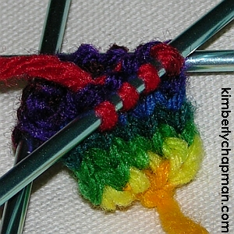[d] | Start a basic tube. This can be done from the total stitches needed, or as shown here, starting from a point and adding stitches until you have your desired total (in this case twelve, or four per needle). I find that it's best to have a couple of normal rows knitted all the way around before starting a twist.
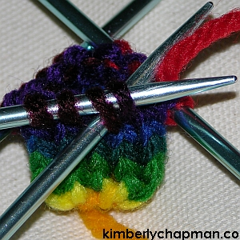[d] | At the start of a row, knit two stitches together to drop one. I find that it's easiest to insert the double-pointed needle backwards through the first two stitches and then down, rather than coming in from behind the second stitch in the row.
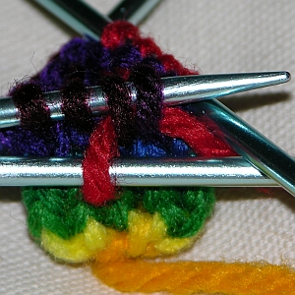[d] | As with normal knitting two together, pull the loop through and then leave the new stitch on the new needle.
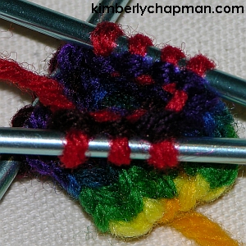[d] | Finish knitting this section. You will be left with one stitch less than a normal count for this needle (in this case, three stitches).
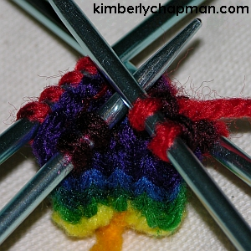[d] | On the next needle (which should be your middle/second needle), knit halfway along. If you have an odd number, decide at the start whether you will be rounding up or down, but stay consistent to that through the whole piece. I generally round up, so if there were five stitches, I'd knit three.
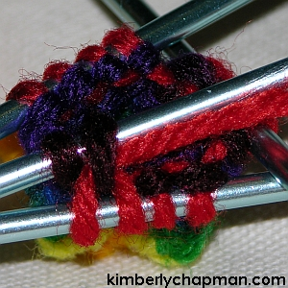[d] | Put the yarn over the needle to add a stitch, as a normal yarn-over move. Then knit the next stitch.
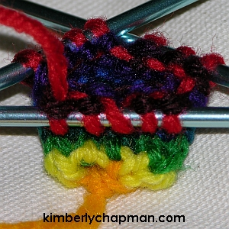[d] | Complete the row along this needle with normal knitting. You can see the added stitch in the photo. This needle should now have one more than the usual count; in this case, a total of five stitches.
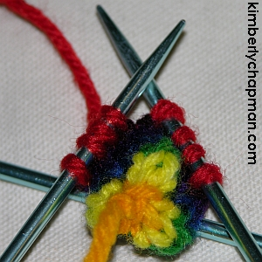[d] | As you repeat this, the middle needle will always have extra stitches and the first needle will run out if you don't even them up. Simply slide the stitch on the end of the middle needle closest to the first needle over onto the first needle. Be sure to move it directly, not twisting it at all. In this photo from below, you can see that the first and second needles each have four stitches again now.
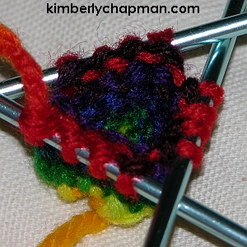[d] | Knit along the third needle as normal to complete the entire row. The count on this needle will never change. That's what makes the twist happen: the fact that you're continually moving/feeding extra on the other needles and not touching this one.
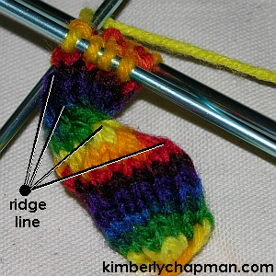[d] | Simply continue to repeat the above steps over and over, and soon you'll see a twist emerge. Where you've been dropping stitches (knitting two together), you'll start to see a ridge line forming. Should you forget what point you're at when you've put the knitting down for awhile and then come back to it (if like me you don't bother with row markers), simply locate this obvious ridge. Wherever it joins a needle, that's where you want to knit two together again.
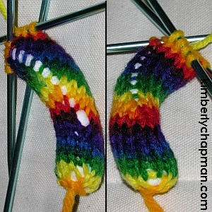[d] | I strongly suggest stuffing the tube every few inches, because as it twists it gets harder to push stuffing down through it. Be sure to stuff as rigidly as you intend for the final piece, since it's almost impossible to cram stuffing down beyond a few inches.  Once you start stuffing the piece, you will see big holes where you've added stitches (left side of the photo), and smaller ones where you've been dropping stitches (right side of the photo along the aforementioned ridge line). Depending on the desired outcome, you could either leave the holes as they are, stitch them closed, or my favourite technique as shown below: weaving other yarn through them.  If you find that you haven't stuffed enough, you can use these holes to push in extra stuffing, but you have to work with small amounts and it can be rather fiddly.
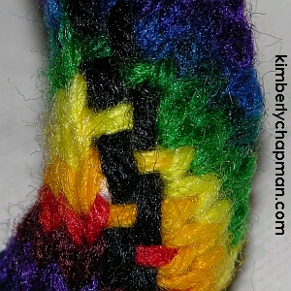[d] | For the bigger holes, I recommend weaving multiple times through to cover up the stuffing. The yarn you use can be anything you want. In this case I chose black because it best complimented the rainbow, whereas using the rainbow yarn ended up with mismatched colours along the rows themselves. I wove the black yarn through from end to end once, using a yarn needle, and then back again the other way with an opposing weave (hence the step look). You could also weave the same both ways, or weave two rows through at once, or as in the case of my big green snake, I wove a yellow, orange, and red line through simultaneously because the holes on that piece were very large.
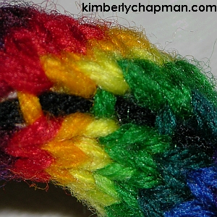[d] | Similarly, for the smaller holes, weave through once or twice, as required/desired. The size of these holes depends strongly on how well-stuffed the piece is. A softly stuffed piece may not require any weaving on the ridge line at all. The yarn you use here doesn't have to be the same as what you used on the other holes; for my big green snake, I used matching green yarn on this line.

Right-Handed Twist
Thanks to input and tests from lots of friendly folks, I've finally figured out how to do a right-handed twist as needed for my DNA model. At first I just tried shifting the increase and decrease, then I tried shifting the flow of stitches, but neither worked. It seems you have to do both, so my apologies for not getting it right for so long!
Many people suggested alternate means of increasing or decreasing, but as my sample below shows, that doesn't matter so much as long as you do the increasing and decreasing in a way that shifts the stitches the proper way around.
The sample below increased the first stitch on the first needle using a knit back-and-front addition and decreasing at the midpoint of the second needle using a single cast-off stitch. Once it was clear that the tube was twisting to the right, I reverted to my preferred yarn-over and knit-two-together method, ensuring that the yarn over was done between the first and second stitches on the first needle, and the two together was always the last third and fourth stitch on the second needle. Shifting was done from needle one to needle two.
You can see that the twist continues regardless of how the increases or decreases are done, but the various stitches produce different types of bumps. All of the increases produced holes, but the yarn-over is smoother in my opinion, especially for varigated yarn. The diagram shows where to add, shift, and decrease to make the tube twist to the right:
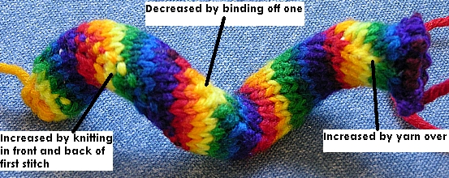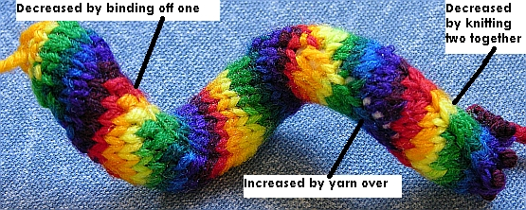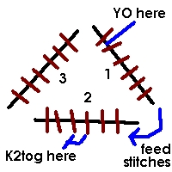

Inside-out
I haven't taken a picture of this one, but I did turn a tube inside-out and it didn't reverse the direction. Furthermore, for the DNA model in particular, one must stuff as one knits in order to achieve a suitable firmness to the stuffing. Waiting until the end - which turning it inside-out would require - means less compacted stuffing.

Knitting backwards
I haven't tried it myself, but several people report success in knitting backwards or to the left.

